**FORCES IN NATURE**

Folding

If rocks move gradually towards each other then the layers of rock can form folds.

If a fold is ∪-shaped it is called a **syncline**. (trough)

If a fold is ∩-shaped it is called an **anticline**. (arch)

A single sided bend with a - shape is called a **monocline.**

Faulting

Sudden movements, such as earthquakes, can cause breaks or cracks in rocks called **faults.** They can be on a small scale or like the Darling Fault scarp can be hundreds of kilometres long.

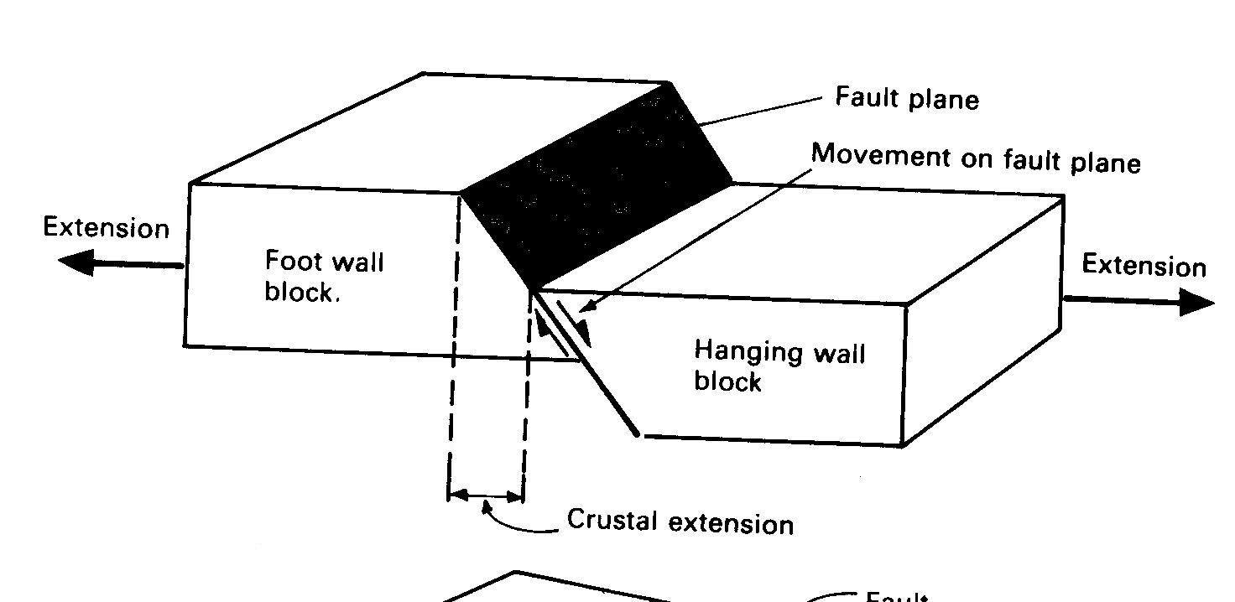Normal faults are produced by tension forces that result in crustal extension. The formation of the Darling Scarp is an excellent example.

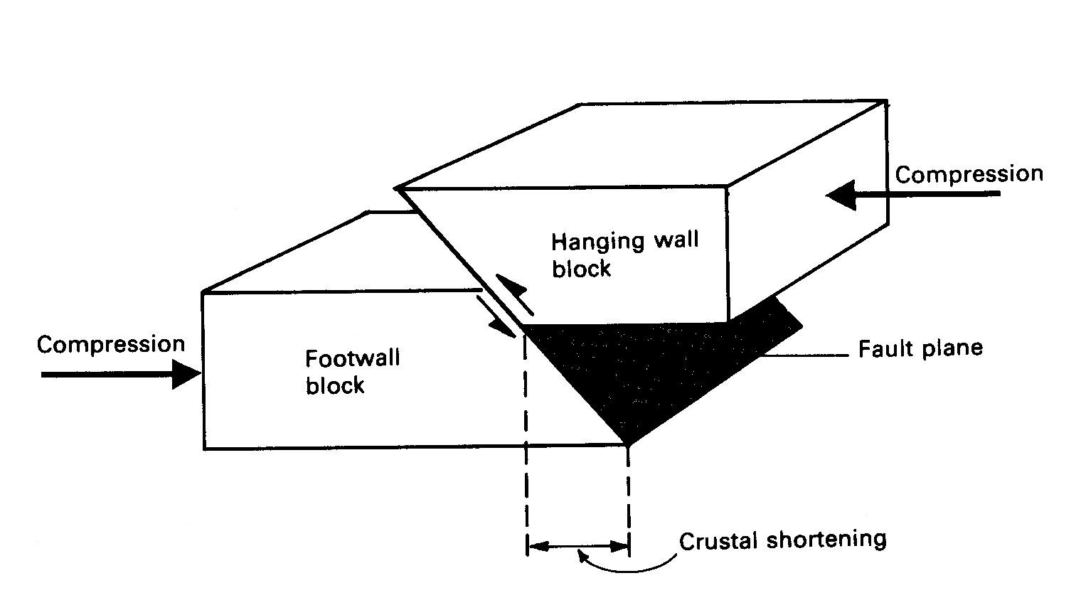

Reverse faults are produced by compression forces that result in crustal shortening